Request for Study Abroad PL 117-333, Section 9 Extension Facility Code
If your course meets the requirements of PL 117-33, Section 9, please copy this entire template (page 1 and 2) onto institution letterhead. The template must be completed prior to reporting enrollment of any student approved for Study Abroad under Section 9.
NOTE: Please do not submit this request unless there is at least one student enrolled in a program that requires this action.
Once submitted, an assignment of an institution Study Abroad Section 9 Extension Code will be provided to the institution to ensure the proper payment of monthly housing allowance (MHA) for Post 9/11 GI Bill students.
This request must be submitted to the VA as indicated below. This action does not require State Approving Agency (SAA) approval.
When utilizing a Study Abroad Section 9 agreement with a foreign school, the U.S. based IHL agrees to assume responsibility for the quality and content of the covered study abroad course(s) and to serve as the school certifying official (SCO). Please submit the completed template to the applicable email address as indicated on the jurisdictional map:
Central - ESUCENTRAL.VBASTL@va.gov
East - EASTREGIONCL.VBABUF@va.gov
South - EDUSVCSOUTH.VBAATG@va.gov
West - EDUESU.VBAMUS@va.gov
(These mailboxes are not intended for general inquiries regarding other school/VA related matters.)
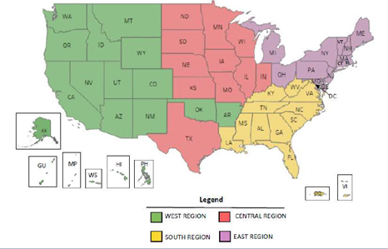
IMPORTANT: The IHL should request one (1) Study Abroad Section 9 Extension Code. Students studying under any Study Abroad Section 9 arrangement through your IHL should be certified using the same Section 9 sub-facility code. If your IHL includes branch campuses with distinct facility codes that may send students overseas, each campus must request its own Study Abroad Section 9 Extension Code.

NAME AND ADDRESS OF REQUESTING IHL | FC CODE OF REQUESTING IHL  (8 Digit Number)
Print Name of Authorizing Official | Title of Authorizing Official
Signature of Authorizing Official | Telephone Number | Date Signed

FOR VA USE ONLY
Section 9 Extension Site Sub-Facility Code Assigned:

Education Liaison Representative Signature | Date Signed

